Week-03 HandsOn Solution

- EF Core 8.0 HOL

Lab 1: Understanding ORM with a Retail Inventory System

- Code:

//Model.cs

using System.Collections.Generic;
using Microsoft.EntityFrameworkCore;

namespace Models
{
public class Category
{
public int Id { get; set; }
public string Name { get; set; }
public List<Product> Products { get; set; } = new();
}

public class Product
{
public int Id { get; set; }
public string Name { get; set; }
public decimal Price { get; set; }
public int CategoryId { get; set; }
public Category Category { get; set; }
}

public class AppDbContext : DbContext
{
public DbSet<Product> Products { get; set; }
public DbSet<Category> Categories { get; set; }

protected override void OnConfiguring(DbContextOptionsBuilder optionsBuilder)
{
optionsBuilder.UseSqlServer("Server=(localdb)\\mssqllocaldb;Database=RetailDb;Trusted_Connection=True;");
}
}
}

//Program.cs

Lab 1: ORM Concepts - No code required

Lab 2: Setting Up the Database Context for a Retail Store

- Code:

//Model.cs

using System.Collections.Generic;
using Microsoft.EntityFrameworkCore;

namespace Models
{
public class Category
{
public int Id { get; set; }
public string Name { get; set; }
public List<Product> Products { get; set; } = new();
}

public class Product
{
public int Id { get; set; }
public string Name { get; set; }
public decimal Price { get; set; }
public int CategoryId { get; set; }
public Category Category { get; set; }
}

public class AppDbContext : DbContext
{
public DbSet<Product> Products { get; set; }
public DbSet<Category> Categories { get; set; }

protected override void OnConfiguring(DbContextOptionsBuilder optionsBuilder)
{
optionsBuilder.UseSqlServer("Server=localhost\\SQLEXPRESS01;Database=RetailDb;Trusted_Connection=True;Encrypt=False;");

}
}
}

//Program.cs

using System;
using Microsoft.EntityFrameworkCore;
using Models;

class Program
{
static void Main()
{
using var context = new AppDbContext();

if (context.Database.CanConnect())
{
Console.WriteLine("Lab 2 setup successful — Models and DbContext are working.");
}
else
{
Console.WriteLine("Lab 2 — Cannot connect to the database. Check your connection string.");
}
}
}
- Output:

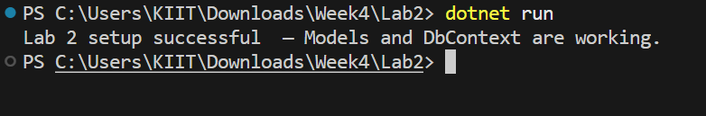

Lab 3: Using EF Core CLI to Create and Apply Migrations

- Code:

//Models.cs

using System.Collections.Generic;
using Microsoft.EntityFrameworkCore;

namespace Models
{
public class Category
{
public int Id { get; set; }
public string Name { get; set; }
public List<Product> Products { get; set; } = new();
}

public class Product
{
public int Id { get; set; }
public string Name { get; set; }
public decimal Price { get; set; }
public int CategoryId { get; set; }
public Category Category { get; set; }
}

public class AppDbContext : DbContext
{
public DbSet<Product> Products { get; set; }
public DbSet<Category> Categories { get; set; }

protected override void OnConfiguring(DbContextOptionsBuilder optionsBuilder)
{
optionsBuilder.UseSqlServer("Server=localhost\\SQLEXPRESS01;Database=RetailDb;Trusted_Connection=True;Encrypt=False;");
}
}
}

//Program.cs

using Models;
using System;
class Program
{
static void Main()
{
Console.WriteLine("Run migrations using the following commands:");
Console.WriteLine("dotnet ef migrations add InitialCreate");
Console.WriteLine("dotnet ef database update");
}
}

- Output:

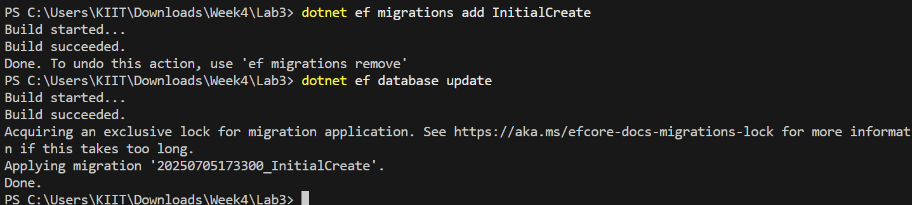

Lab 4: Inserting Initial Data into the Database

- Code:

//Models.cs

using System.Collections.Generic;
using Microsoft.EntityFrameworkCore;

namespace Models
{
public class Category
{
public int Id { get; set; }
public string Name { get; set; }
public List<Product> Products { get; set; } = new();
}

public class Product
{
public int Id { get; set; }
public string Name { get; set; }
public decimal Price { get; set; }
public int CategoryId { get; set; }
public Category Category { get; set; }
}

public class AppDbContext : DbContext
{
public DbSet<Product> Products { get; set; }
public DbSet<Category> Categories { get; set; }

protected override void OnConfiguring(DbContextOptionsBuilder optionsBuilder)
{
optionsBuilder.UseSqlServer("Server=localhost\\SQLEXPRESS01;Database=RetailDb;Trusted_Connection=True;Encrypt=False;");

}
}
}

//Program.cs

using System;
using System.Threading.Tasks;
using Models;

class Program
{
public static async Task Main()
{
using var context = new AppDbContext();

var electronics = new Category { Name = "Electronics" };
var groceries = new Category { Name = "Groceries" };

await context.Categories.AddRangeAsync(electronics, groceries);

var product1 = new Product { Name = "Laptop", Price = 75000, Category = electronics };
var product2 = new Product { Name = "Rice Bag", Price = 1200, Category = groceries };

await context.Products.AddRangeAsync(product1, product2);
await context.SaveChangesAsync();
Console.WriteLine("Data inserted successfully into RetailDb.");

}

}

- Output:

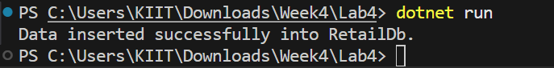

Lab 5: Retrieving Data from the Database

- Code:

//Models.cs

using System.Collections.Generic;
using Microsoft.EntityFrameworkCore;

namespace Models
{
public class Category
{
public int Id { get; set; }
public string Name { get; set; }
public List<Product> Products { get; set; } = new();
}

public class Product
{
public int Id { get; set; }
public string Name { get; set; }
public decimal Price { get; set; }
public int CategoryId { get; set; }
public Category Category { get; set; }
}

public class AppDbContext : DbContext
{
public DbSet<Product> Products { get; set; }
public DbSet<Category> Categories { get; set; }

protected override void OnConfiguring(DbContextOptionsBuilder optionsBuilder)
{
optionsBuilder.UseSqlServer("Server=localhost\\SQLEXPRESS01;Database=RetailDb;Trusted_Connection=True;Encrypt=False;");

}
}
}

//Program.cs

using System;
using System.Threading.Tasks;
using Microsoft.EntityFrameworkCore;
using Models;

class Program
{
public static async Task Main()
{
using var context = new AppDbContext();

var products = await context.Products.ToListAsync();
foreach (var p in products)
Console.WriteLine($"{p.Name} - ₹{p.Price}");

var product = await context.Products.FindAsync(1);
Console.WriteLine($"Found: {product?.Name}");

var expensive = await context.Products.FirstOrDefaultAsync(p => p.Price > 50000);
Console.WriteLine($"Expensive: {expensive?.Name}");
}
}

- Output:

